Introduction to Databases

Databases are of two type :

1. Relational DB 🡪 Oracle, Mysql, SQLServer
2. Non-Relational DB 🡪 Recently developed 🡪 MongoDB

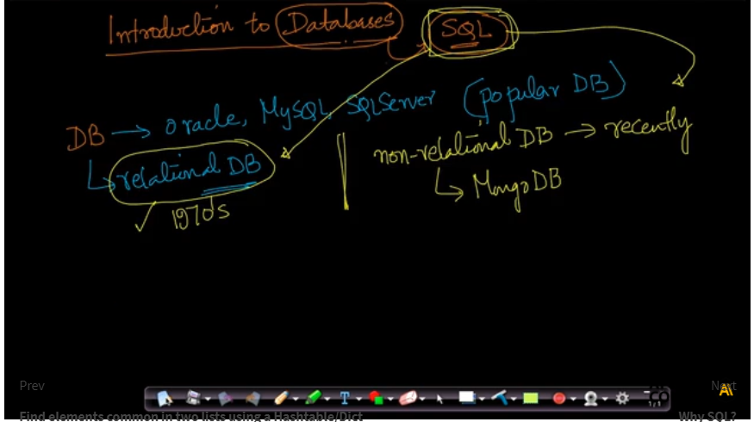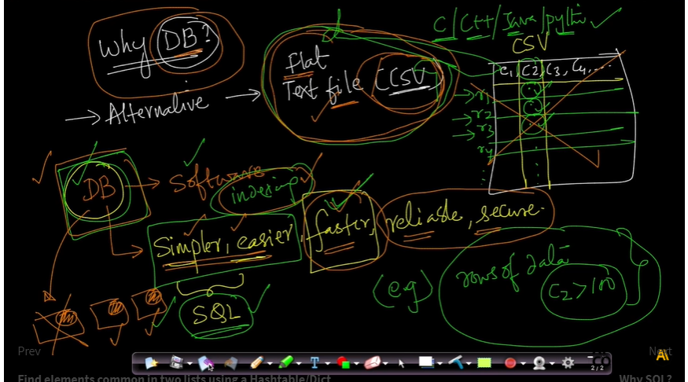

Why don’t we user Text file or flat file, we use Database instead of that, this is because DB help us in order organize or fetch the data on the go using SQL.

DB Software 🡪 Simpler, easier, faster, reliable and secure. (DB uses indexing which is very helpful in order to fetch the data). DB help us obtaining data that we want in simpler, easier, faster, reliable and secure manner. That’s why we use DB instead of flat files.

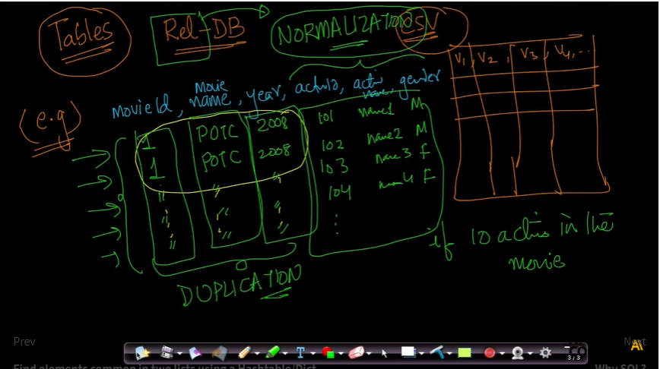

In relational DB our data is stored in multiple tables. Let’s assume I have movie data, containing column as movie_id, movie_name, year, actor_id, actor_name, gender.

Now, in 1 movie let say POC there are many actors, if we use one table, we have to repeat lots of data. Here, comes the concept of Normalization, which eliminate the repetition by breaking up data into multiple tables.

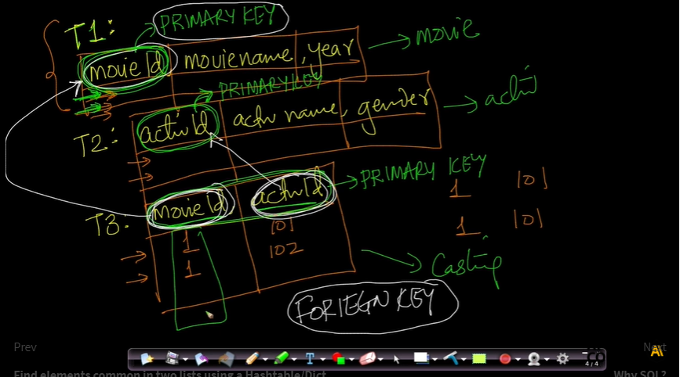

So, we use multiple tables in order to eliminate the duplication of data. This breaking of tables into multiple tables is known as normalization in DB. Here, from one big table we created 3 tables t1(movie_table)🡪 movie_id, movie_name,year, t2(actor_table)🡪 actor_id, actor_name, gender, t3(casting_table)🡪 movie_id,actor_id

Here, In t1(movie_table)🡪 movie_id, movie_name,year, we can uniquely identify each row by using movie_id. So, it is called as Primary Key here.

In, t2(actor_table)🡪 actor_id, actor_name, gender, Primary Key = actor_id

In, t3(casting_table)🡪 movie_id,actor_id, Primary Key = (movie_id and actor_id) as by using both we can uniquely identify each row in the casting table.

Modie_id and actor_id are the foreign key in movie_table and actor_table respectively.

[Why SQL?](https://beta.appliedaicourse.com/lecture/11/applied-machine-learning-online-course/3476/why-sql/1/module-1-fundamentals-of-programming)

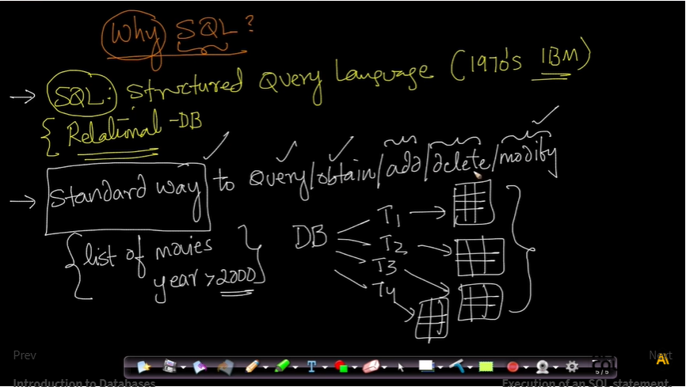

SQL stands for Structured Query Language, which was developed in 1970 by bunch of researchers at IBM Labs. SQL is mainly used in Relational DB in order to query the data from the table. SQL is a standard way of obtaining/Adding/Deleting/Modifying the databases.

Let say we have multiple tables in the Movie DB, and we want to find out “list of movies which is released after the year 2000”. So, here we just write the query, and we get the desired data.

SQL is very widely used in the industry as every decision is data driven now. So, storing and fetching the data is very important in order to survive in the industry.

Hence, learning SQL and Databases are very important now a days and it is also very easy to learn the SQL and it is used by many non-engineers also.

Learning SQL is very important if you want to became a Data Scientist, ML Engineer or even Data Analyst.

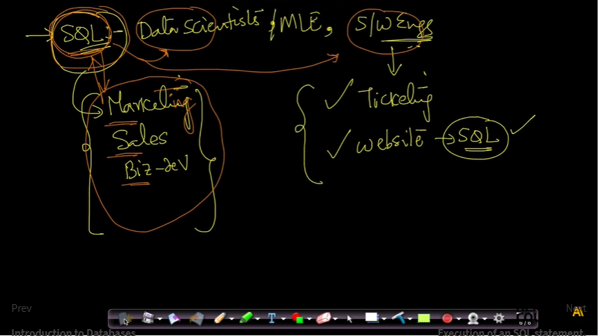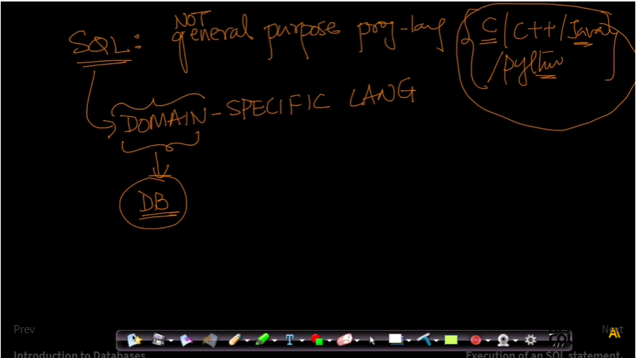

Now, comes what exactly is SQL (Structured Query Language) it is not a general-purpose programming language like C, C++, Python etc… It is domain specific it is related to Databases only. Here, by using SQL we can only execute the query.

C/C++/Python these are procedural programming language which means, we must write step by step procedure in order to perform any task, but on the other hand SQL is declarative language which we don’t have to mention the step how to get the data, we only need to write what we want that’s it.

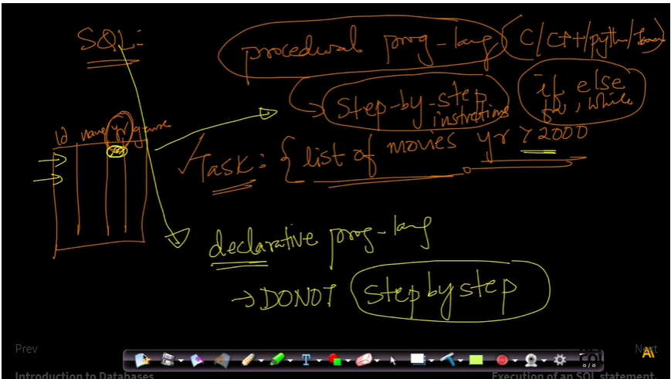

[Execution of an SQL statement.](https://beta.appliedaicourse.com/lecture/11/applied-machine-learning-online-course/3477/execution-of-an-sql-statement/1/module-1-fundamentals-of-programming)

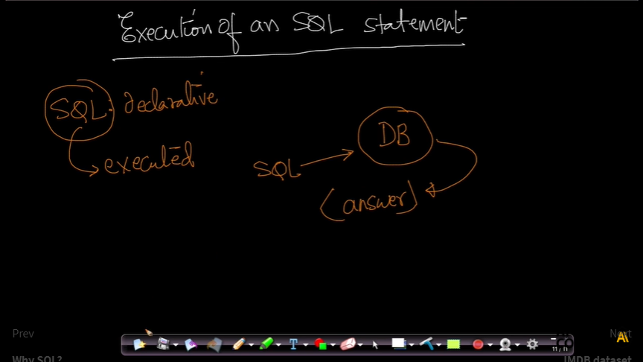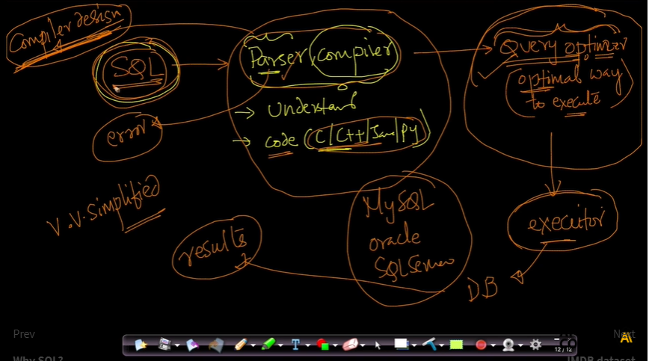

[IMDB dataset](https://beta.appliedaicourse.com/lecture/11/applied-machine-learning-online-course/3478/imdb-dataset/1/module-1-fundamentals-of-programming)

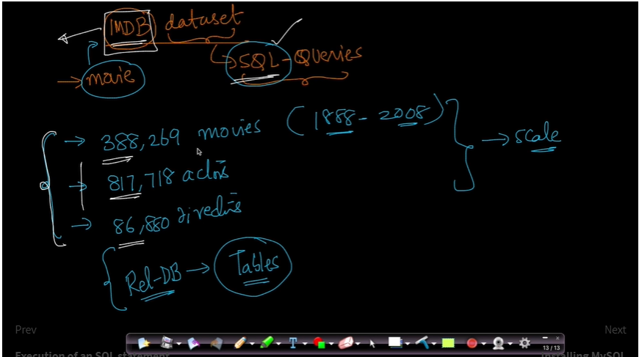

[SELECT](https://beta.appliedaicourse.com/lecture/11/applied-machine-learning-online-course/3482/select/1/module-1-fundamentals-of-programming)

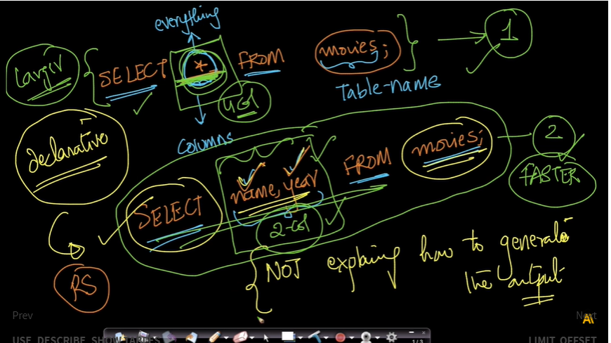

[LIMIT, OFFSET](https://beta.appliedaicourse.com/lecture/11/applied-machine-learning-online-course/3483/limit-offset/1/module-1-fundamentals-of-programming)

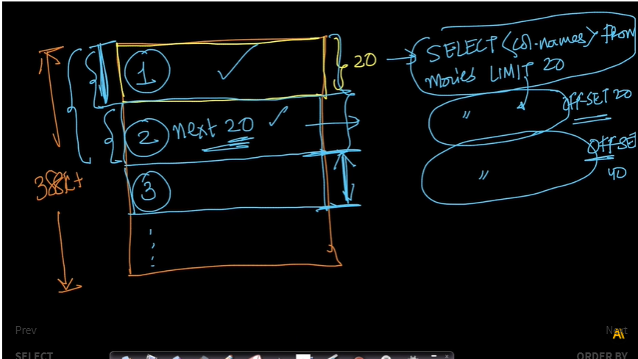

[Inner, Left, Right and Outer joins.](https://beta.appliedaicourse.com/lecture/11/applied-machine-learning-online-course/3493/inner-left-right-and-outer-joins/1/module-1-fundamentals-of-programming) 